**Database Management System**

**Practical 1**

**Draw an E-R diagram from given entities and their attributes**

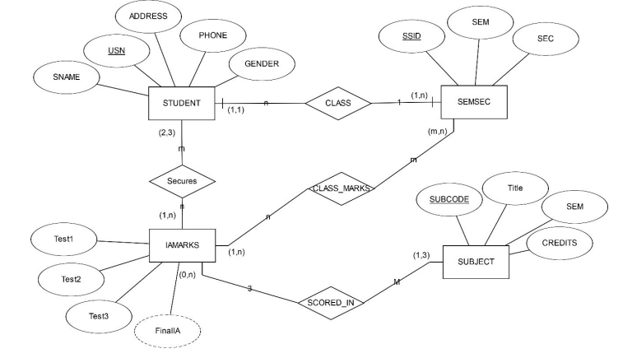

**Practical 2**

**Convert the E-R diagram into a Relational model with proper constraints.**

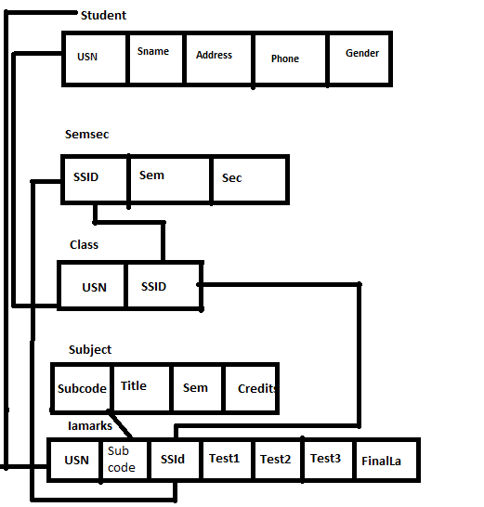

**Practical 3**

**AIM:- Write queries to execute following DDL commands :**

CREATE :Create the structure of a table with at least five columns

ALTER: Change the size of a particular column.

* Add a new column to the existing table.
* Remove a column from the table.

DROP: Destroy the table along with its data.

1. **Create** a database .
   1. create database company;



1. **Create** Table and Insert four columns.

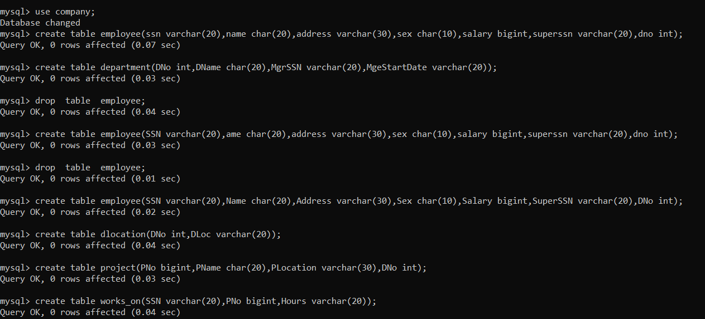

1. **ALTER**

Change the size of a particular column.

1. **ALTER TABLE student modify Gender char(8);**

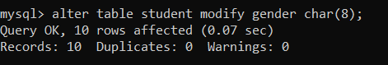

Add a new column to existing Table.

* 1. **ALTER Table student add(shift char(5);**

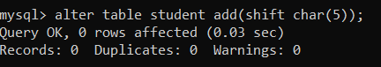

1. Delete a column from Existing Table;
   1. **alter Table student DROP column shift;**

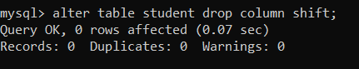

1. **DROP:**

Destroy TABLE Along with its data

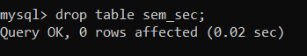

**practical-4**

**AIM:-** **Write queries to execute following DML commands :**

**INSERT: Insert five records in each table.**

**UPDATE: Modify data in single and multiple columns in a table**

**DELETE: Delete selective and all records from a table**

**INSERT**

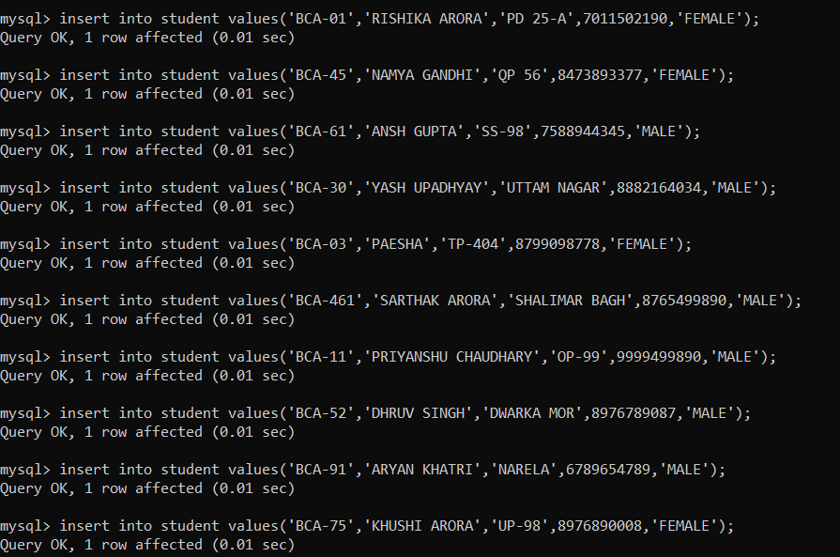

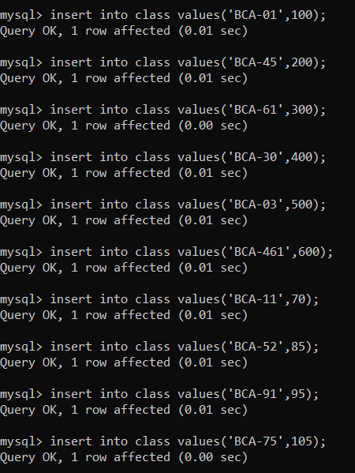

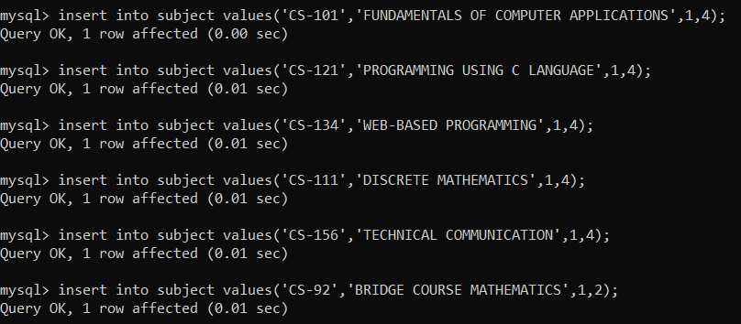

**UPDATE**

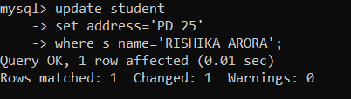

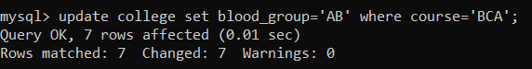

**DELETE**





**Practical 5**

**AIM:-** **Write queries to execute following DML command :**

**SELECT:**

Retrieve the entire contents of the table.

Retrieve the selective contents (based on provided conditions) from a table.

Retrieve contents from a table based on various operators i.e. string operators,

logical operators and conditional operators,Boolean operators.

Sort the data in ascending and descending order in a table on the basis of one

column or more than one column.

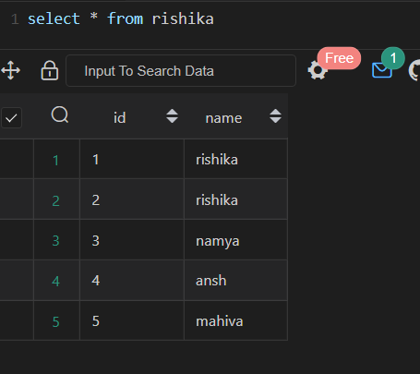

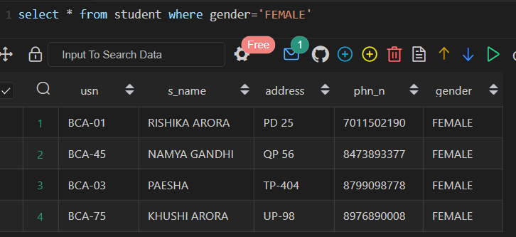

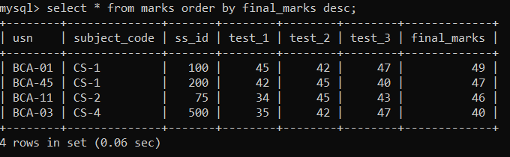

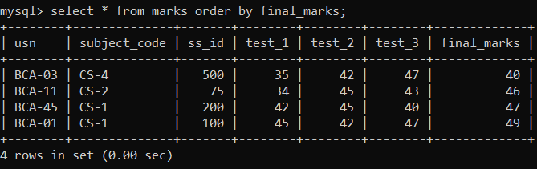

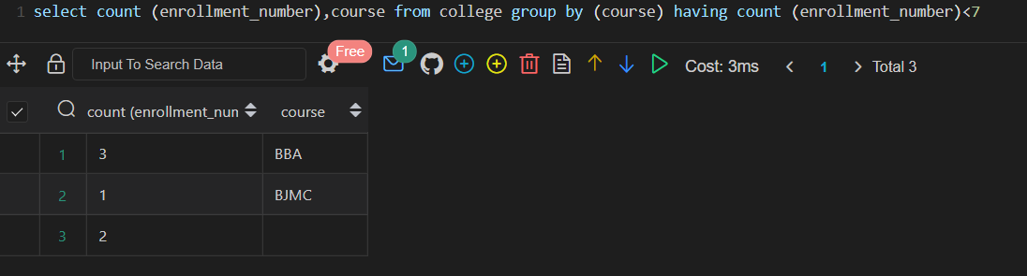

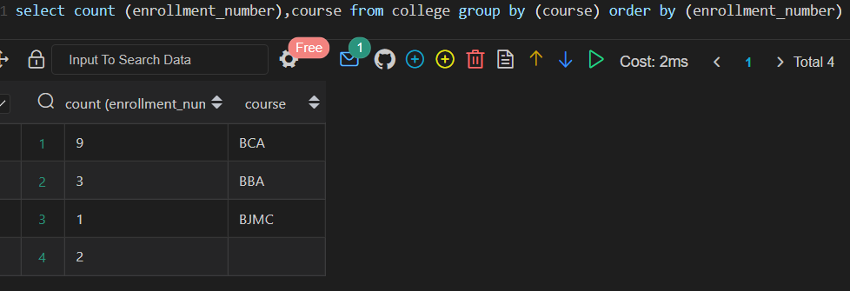

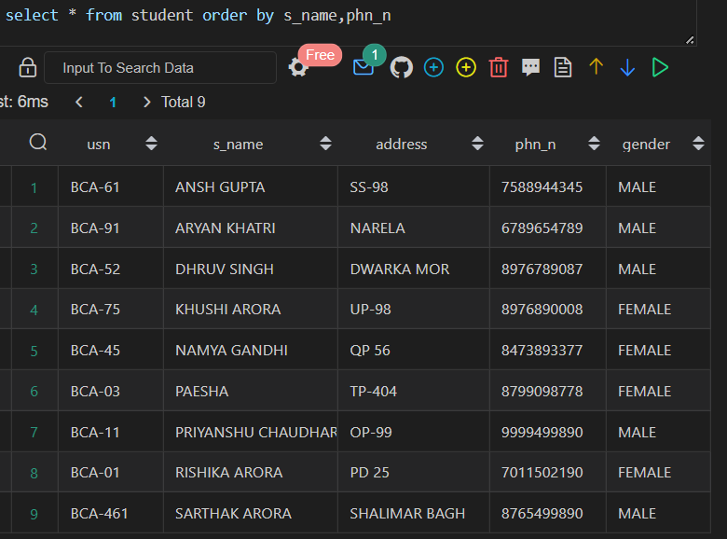

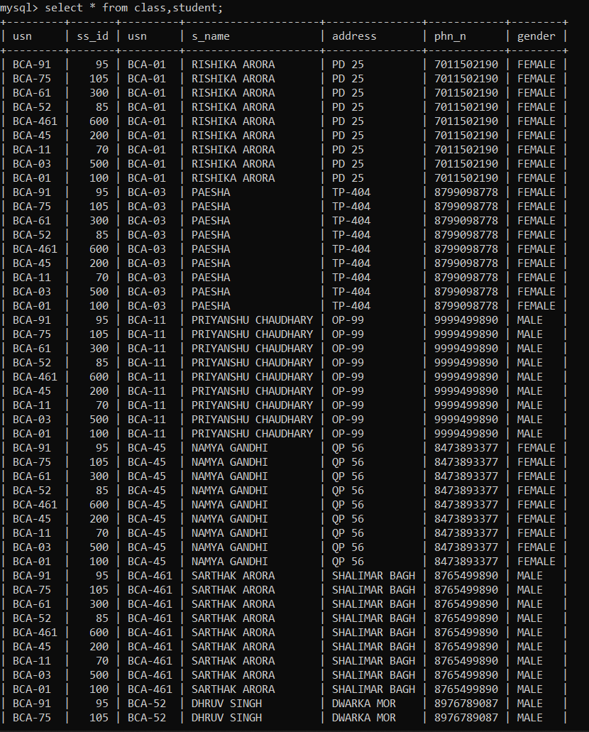

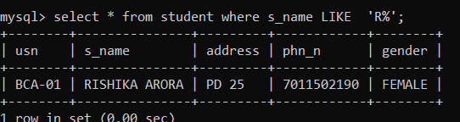

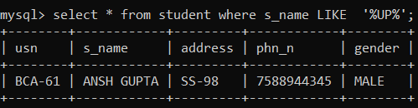

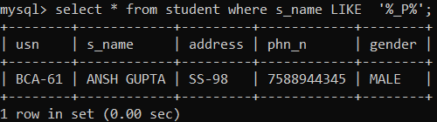

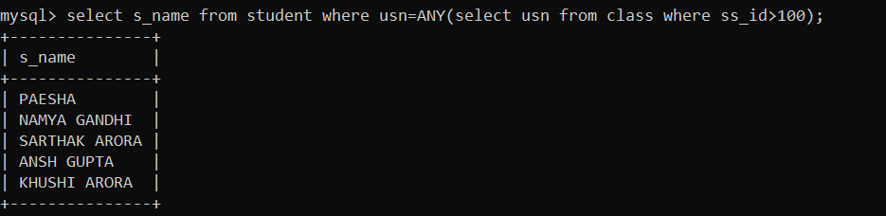

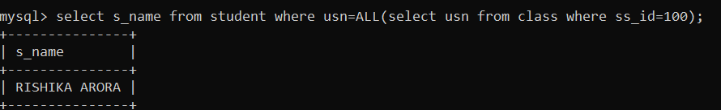

**Practical 6**

**Create table using following integrity constraints:**

* **Primary Key**
* **Unique Key**
* **Not Null**
* **Check**
* **Default**
* **Foreign Key**



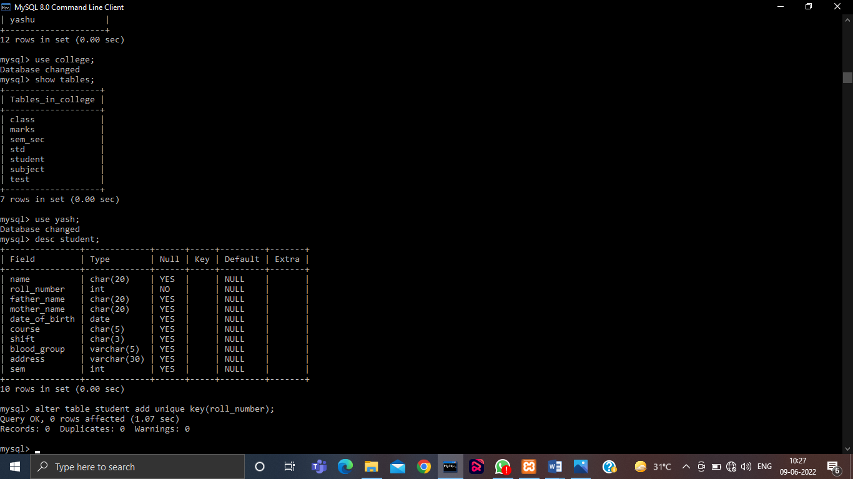



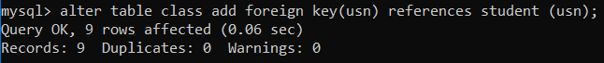



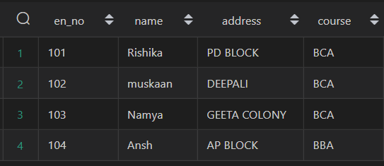

**Practical 7**

**Write queries to execute following Aggregate functions**

**Sum, Avg, Count, Minimum and Maximum value of a numeric column of a table using aggregate function**

Query:-

Select sum(<column_name>) from <table_name>;

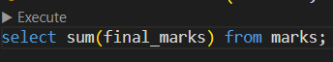

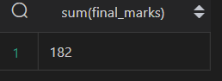

Select avg(<column_name>) from <table_name>;





Select min(<column_name>) from <table_name>;





Select max(<column_name>) from <table_name>;





**Practical 8**

**Retrieve data from a table using alias names .**

Query: -

Select <column_name with change> as ‘Name’ from <table_name>;

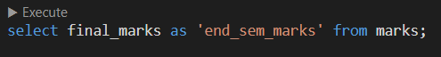

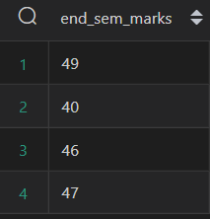

**Practical 9**

**Retieve data from a table using nested Queries.**

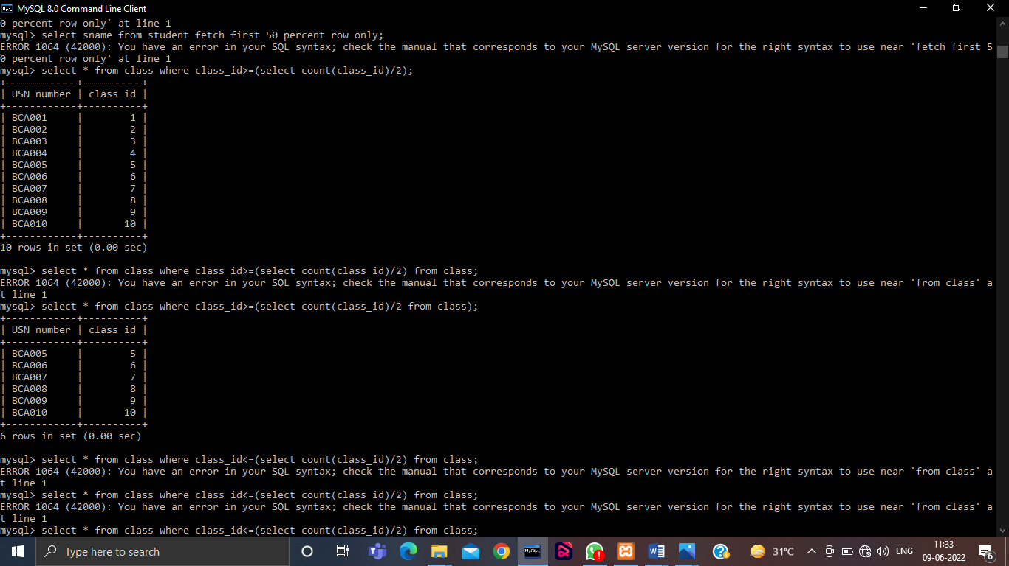



**Practical 10**

**Retrieve data from more than one table using inner join, left outer, right outer and full outer joins**

Query:-

**Inner join**

SELECT column_name(s)  
FROM table1  
INNER JOIN table2ON table1.column_name = table2.column_name;

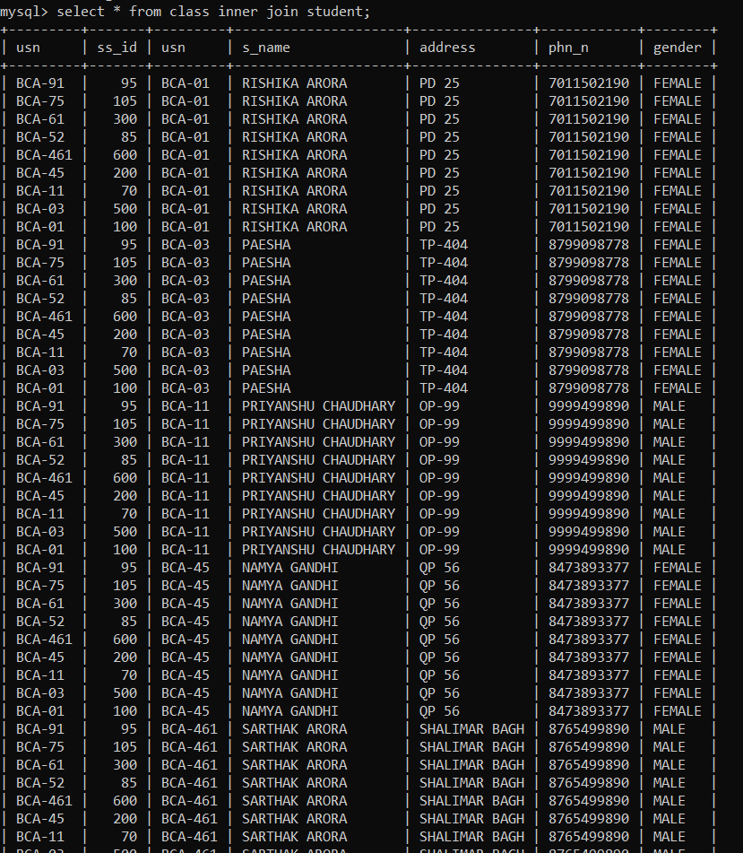

**Left Join**

SELECT column_name(s)  
FROM table1  
LEFT JOIN table2ON table1.column_name = table2.column_name;

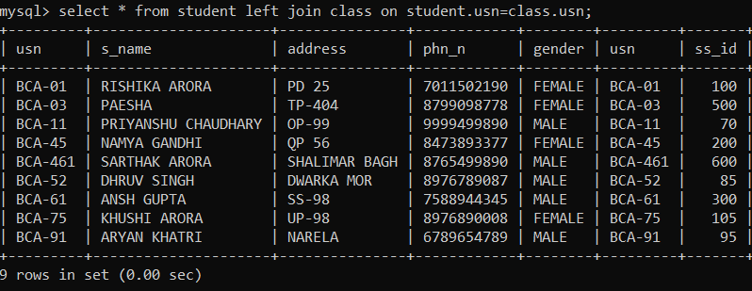

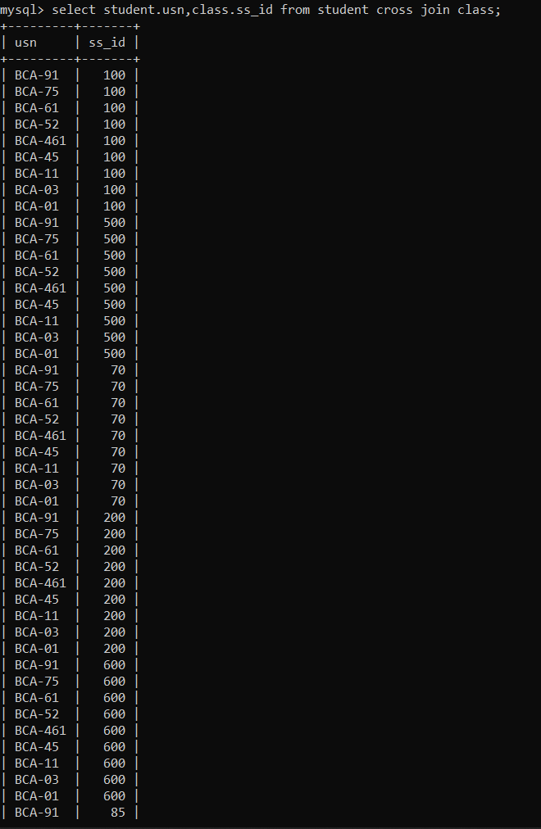

**Practical 11**

**Create view from one table and more than one table.**



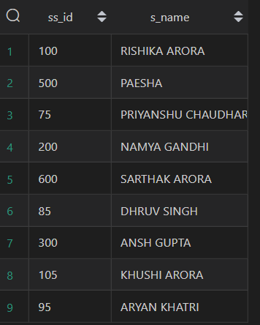

**Practical 13**

Consider the Insurance company’s Database given below. The primary keys are underlined and the data typesare specified.

* PERSON(driver_id# : string, name : string, address : string)
* CAR(regno : string, model : string, year : int)
* ACCIDENT(report_number : int, acc_date : date, location : string)
* OWNS(driver_id# : string, regno : string)
* PARTICIPATED(driver_id# : string, regno : string, report_number : int, damage_amount :number(10,2) )

(i) Create the above tables by properly specified the primary key and the foreign key

(ii) Enter at least five tuples for each relation

(iii) Demonstrate how you can

a. Update the damage amount for the car with a specific regno, the accident with report number 12 to 25000.

b. Add a new accident to the database.

(iv) Find the total number of people who owned cars that were involved in accident in 2002.

Find the number of accident in which cars belonging to a specific models were involved

**i)**











**ii)**

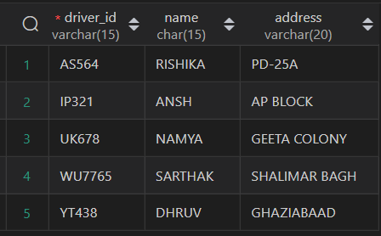

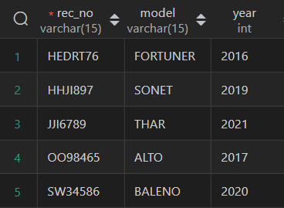

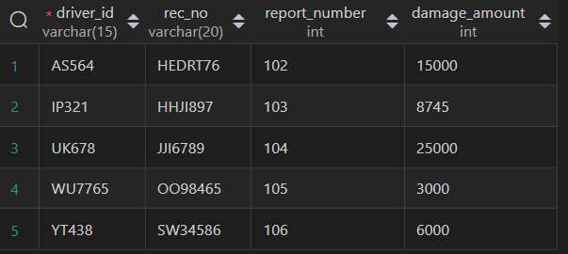

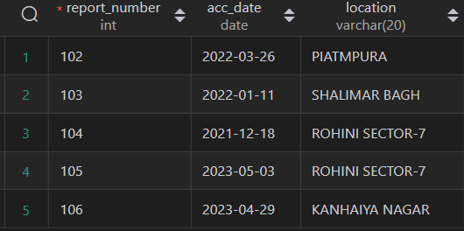

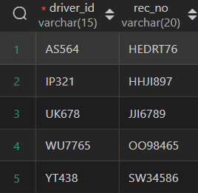

**iii)**





**iv)**

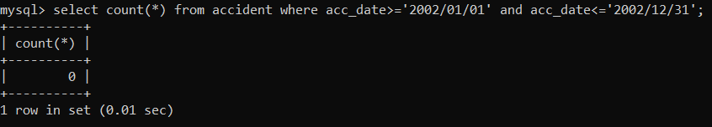

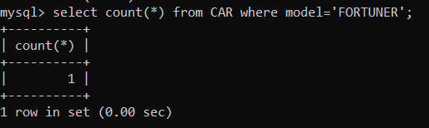

**Practical 14**

Consider the following schema of a library management system.Write the SQL queries for the questions given below;

Student(Stud_no : integer, Stud_name: string)

Membership(Mem_no: integer, Stud_no: integer)

Book_(book_no: integer, book_name:string, author: string)

lss_rec_(iss_no:integer, iss_date: date, Mem_no: integer, book_no: integer)

(i) Create the tables with the appropriate integrity constraints

(ii) Insert around 10 records in each of the tables

(iii)Display all records for all tables

(iv) List all the student names with their membership numbers

(v) List all the issues for the current date with student and Book names

(vi) List the details of students who borrowed book whose author is Elmarsi & Navathe

(vii) Give a count of how many books have been bought by each student

(viii) Give a list of books taken by student with stud_no as 1005

(ix) Delete the List of books details which are issued as of today

(x) Create a view which lists out the iss_no, iss _date, stud_name, book name

i)

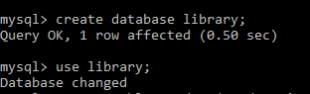

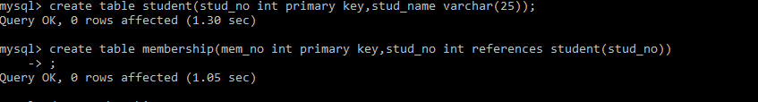 

ii)

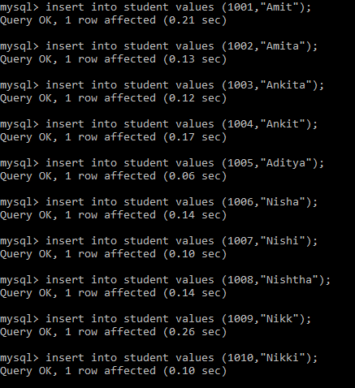

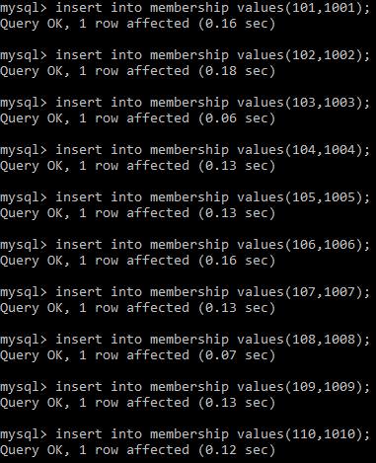

     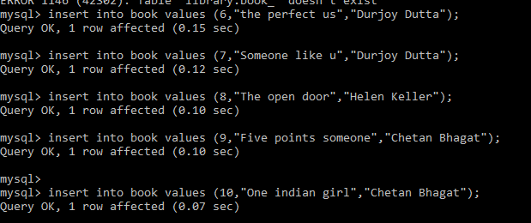

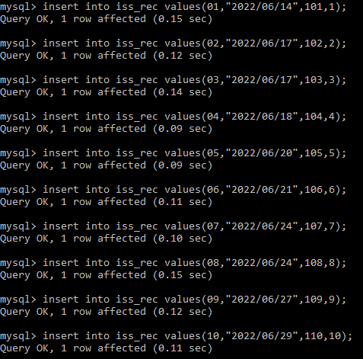

iii)

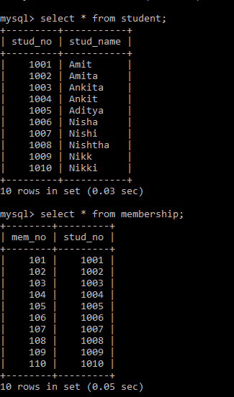 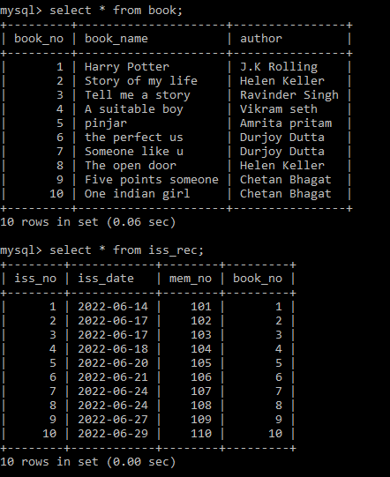

iv) 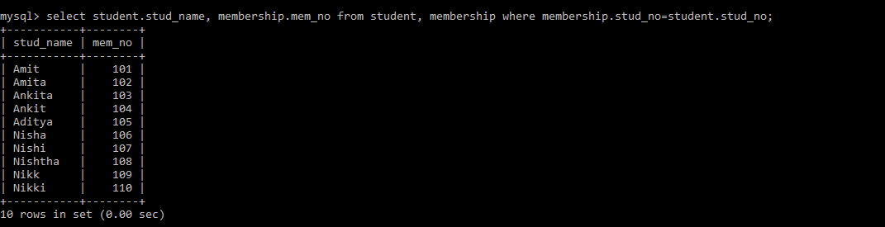

v)

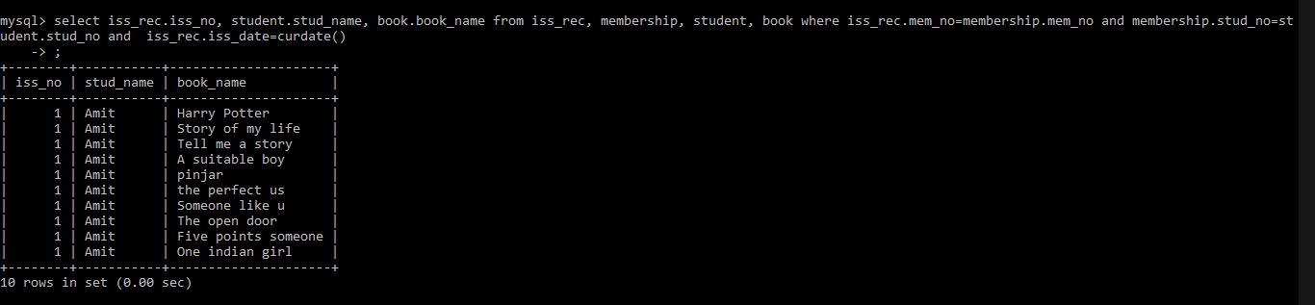

vi) 

vii) 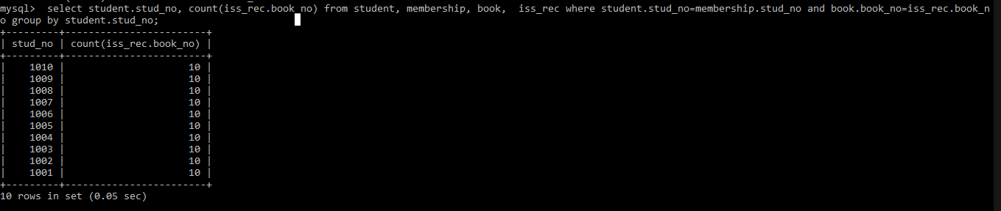viii) 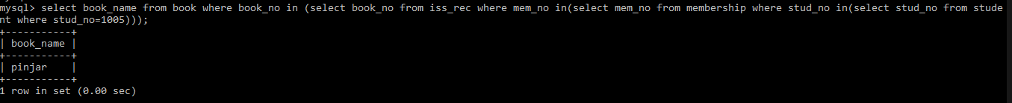ix) 

x) 